Object Oriented Programming – using Python

* **What is OOP?**
  + Explain the concept of organizing code around *objects* and *classes*, relating it to real-world objects (e.g., a dog, a car).

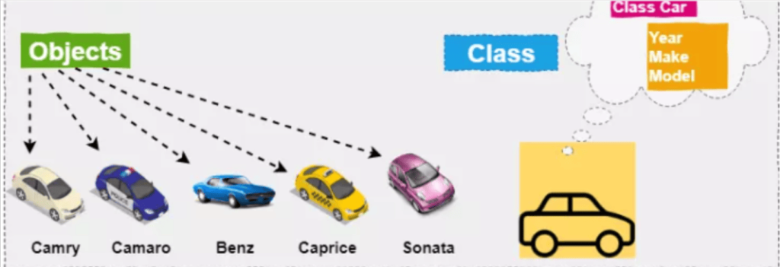

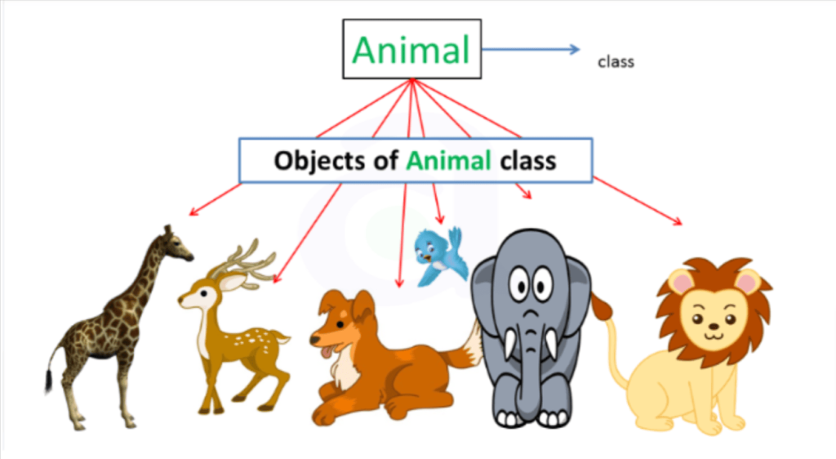

* + Key benefits: reusability, simplicity, and structure.
* **Key Terms:**
  + Class: Blueprint or template (analogy: blueprint of a house).
  + Object: Instance of a class (analogy: an actual house built from the blueprint).

 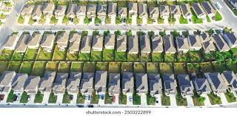

**2. Basic Python OOP**

* **Define a Simple Class**:

class Dog:

def __init__(self, name, breed):

self.name = name

self.breed = breed

* + Explain class, __init__, and self.
  + Introduce attributes as characteristics (name, breed).
* **Create Objects**:

my_dog = Dog("Buddy", "Golden Retriever")

print(my_dog.name, my_dog.breed)

* + Show how to create an object from a class.
  + Make it interactive by asking students for dog names and breeds.

**3. Methods in Classes**

* **Add Methods to the Class**:

class Dog:

def __init__(self, name, breed):

self.name = name

self.breed = breed

def bark(self):

return f"{self.name} says Woof!"

* + Explain how methods are actions that the object can perform.
  + Show the bark method and how it works:

print(my_dog.bark())

**Basic Concepts of OOPs:**

1. **Abstraction: Abstraction in programming is like using a TV remote without knowing its inner workings. It lets us focus on essential actions without needing to understand complex details, making code easier to use and understand.**
2. **Encapsulation: Encapsulation is like putting things in a box and only letting certain people access them, so they stay safe and organized.**
3. **Inheritance: Inheritance is like passing down traits from parents to children; objects can inherit characteristics and behaviours from other objects.**
4. **Polymorphism: Polymorphism is like a superhero changing their powers based on the situation; objects can behave differently depending on the context.**

**Good reference for learning OOPs -**

[**https://www.geeksforgeeks.org/oops-object-oriented-programming-system-for-kids/**](https://www.geeksforgeeks.org/oops-object-oriented-programming-system-for-kids/)